BLOOD ASSASSIN

Character Dossier

# Table of Contents

* Protagonist: Elara Nightshade
* Antagonist: Queen Lysandria
* Contagonist: Seraphiel
* Supporting Characters
* Character Relationships

# ELARA NIGHTSHADE

## The Chosen One (Protagonist)

[Portrait: Elara Nightshade]

### Basic Information

|  |  |
| --- | --- |
| Age | 24 |
| Role | Vampire Assassin, Prophecy-Bearer |
| Myers-Briggs | ISTP (The Virtuoso) |
| Archetype | Hero / Chosen One |
| Fatal Flaw | Fear of Vulnerability |

### Physical Appearance

**Build:** Lean, wiry, and athletic. Built for agility and precision rather than brute strength.  
  
**Skin:** Dusky, with visible scars that serve as a map of her battles.  
  
**Hair:** Shoulder-length dark brown, typically tied back in a braid or bun.  
  
**Eyes:** Piercing gray with penetrating focus.  
  
**Notable Markings:** Jagged scar on left forearm from her first vampire kill. Crescent moon birthmark on collarbone.

### Personality

Analytical and pragmatic, Elara thrives in action. She is a natural problem-solver and fiercely independent but struggles to navigate emotions and relationships.

#### Five Descriptor Words

* Determined
* Guarded
* Stubborn
* Introspective
* Fierce

### Strengths

* Combat Mastery: Exceptional in stealth, hand-to-hand combat, and weapons
* Tactical Intelligence: Quickly assesses surroundings and identifies efficient strategies
* Resilience: Physically and emotionally tough, able to endure under pressure

### Weaknesses

* Stubbornness: Unwillingness to compromise causes friction with allies
* Trust Issues: Reluctant to rely on others, often isolating herself
* Emotional Repression: Sees emotions as distraction, leading to inner turmoil

### Backstory

Elara's parents were killed by vampires when she was a child. Taken in by the Order of the Dagger, she was trained by Caelum Morvant from age 10. Her first mission at 16—a failed assassination—left her physically scarred and emotionally shaken. The Order concealed her vampiric heritage, a revelation that becomes a central turning point in the story.

### Motivations

Primary Goal: Destroy Queen Lysandria and protect humanity from the vampire elite.  
  
Underlying Desire: Prove her worth and justify her existence as the survivor of her family's tragedy.  
  
Evolving Motivation: As she learns about her bloodline and the prophecy, she begins to seek a new identity outside of her role as a hunter.

# QUEEN LYSANDRIA

## The Tyrant (Antagonist)

[Portrait: Queen Lysandria]

### Basic Information

|  |  |
| --- | --- |
| Age | Appears mid-40s (actual age unknown) |
| Role | Vampire Monarch, Primary Antagonist |
| Myers-Briggs | ENTJ (The Commander) |
| Archetype | Villain / Tyrant |
| Fatal Flaw | Fear of Vulnerability / Paranoia |

### Physical Appearance

**Build:** Statuesque and regal, with a commanding presence.  
  
**Skin:** Porcelain-pale, almost unnaturally smooth.  
  
**Hair:** Silky black hair, intricately styled into elegant updos.  
  
**Eyes:** Crimson irises that glow faintly when angered.  
  
**Notable Markings:** Delicate scar across right cheek. Blood-red ruby pendant.

### Personality

Ruthless, calculating, and domineering, Lysandria thrives on control. Her paranoia and distrust of others are both her greatest weapon and her deepest flaw.

#### Five Descriptor Words

* Cunning
* Paranoid
* Charismatic
* Ruthless
* Fearful

### Backstory

Born into the Crimson Court's aristocracy, Lysandria rose to power through cunning and calculated alliances, overthrowing rivals to claim the throne. She spearheaded the Twilight Accord, but her paranoia about maintaining balance has led to harsh enforcement and suppression of dissent. She knows the Bloodbound Prophecy foretells a figure who could destroy or unite the realms, and she sees Elara as an existential threat.

### Motivations

Primary Goal: Maintain her rule over the Crimson Court and ensure the prophecy does not lead to her downfall.  
  
Personal Drive: Avoid vulnerability and retain control at all costs.  
  
Evolving Desire: Her fear pushes her into increasingly extreme actions, creating cracks in her rule.

# SERAPHIEL

## The Fallen Guide (Contagonist)

[Portrait: Seraphiel]

### Basic Information

|  |  |
| --- | --- |
| Age | Immortal (appears mid-30s) |
| Role | Fallen Angel, Reluctant Ally |
| Myers-Briggs | INTJ (The Architect) |
| Archetype | Contagonist / Rogue Ally |
| Fatal Flaw | Obsession with Redemption |

### Physical Appearance

**Build:** Tall and lean, with otherworldly grace.  
  
**Skin:** Pale with faint golden glow that dims during despair.  
  
**Hair:** Silvery-white, falling just below shoulders.  
  
**Eyes:** Stormy blue, deeply expressive and sorrowful.  
  
**Notable Markings:** Jagged scars on back where wings were severed.

### Personality

Visionary and strategic, Seraphiel focuses on the bigger picture and long-term outcomes. He operates with detachment, favoring logic over emotional connection, though his guilt and self-loathing create internal conflict.

#### Five Descriptor Words

* Calculating
* Haunted
* Charismatic
* Cynical
* Devoted

### Backstory

Once a high-ranking celestial being tasked with maintaining balance, Seraphiel defied divine order by choosing to protect humanity during a celestial conflict. His wings were severed, and he was cast out. After wandering the mortal world for centuries, he discovered the Bloodbound Prophecy and became convinced it was his final chance at redemption.

### Motivations

Primary Goal: Fulfill the prophecy by destroying the Nightbringer, believing this will restore balance and secure his redemption.  
  
Personal Drive: Prove his worth to the celestial order—or at least to himself.  
  
Evolving Desire: Questions whether redemption lies in grand gestures or in smaller, selfless acts.

# SUPPORTING CHARACTERS

## Valeria Duskbane

### The Double Agent

Half-vampire spy working for the Order while infiltrating the Crimson Court. Her shifting loyalties make her invaluable but dangerous.

## Lys Greaves

### The Rebel Leader

Pragmatic and battle-hardened leader of the mortal rebellion. Frequently clashes with Elara over priorities and moral approach.

## Caelum Morvant

### The Mentor

Elara's stern and disciplined mentor. His unwavering loyalty to the Order creates tension when secrets about Elara's bloodline are revealed.

## Kieran Vale

### The Scholar

Meticulous historian within the Order. Provides critical insights into prophecy and vampire lore, though his logic conflicts with emotional stakes.

## Mara Veilthorn

### The Rebel Vampire

Exiled vampire with vendetta against Queen Lysandria. Her fiery passion makes her both valuable ally and potential liability.

## Ardyn Kael

### The Quiet Anchor

Grounded blacksmith and rebel sympathizer who provides Elara rare moments of peace away from chaos.

# CHARACTER RELATIONSHIPS

## Elara Nightshade - Key Relationships

**Caelum Morvant (Mentor):** Foundational but deeply strained. The revelation of Elara's bloodline shatters her trust, forcing her to decide whether to forgive or sever ties.

**Seraphiel (Ally):** Begins with deep mistrust. Over time, develops into mutual respect as he helps her confront her fear of vulnerability.

**Queen Lysandria (Antagonist):** Lysandria embodies Elara's greatest fear: becoming a monster through power and paranoia. Their rivalry is intensely personal.

**Ardyn Kael (Love Interest):** Provides rare moments of normalcy and peace. Their quiet connection offers her grounding, though it carries risks.

## Queen Lysandria - Key Relationships

**Elara Nightshade:** Views her as both threat and reflection of her own vulnerabilities. Exploits Elara's insecurities to break her resolve.

**Seraphiel:** Regards him as dangerous outsider with knowledge of prophecy. Respects his intellect but despises his arrogance.

**Valeria Duskbane:** Believes she has Valeria's loyalty but suspects betrayal. Their interactions are fraught with tension.

# Visual Reference Gallery

## Character Portraits

**Elara Nightshade - Portrait**

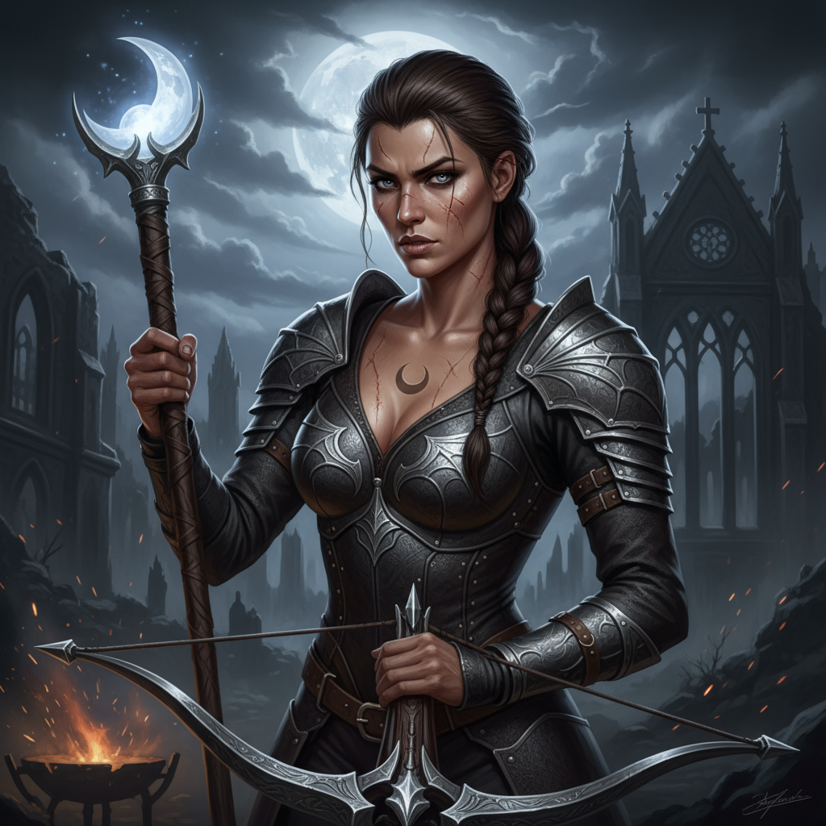

**Queen Lysandria - Portrait**

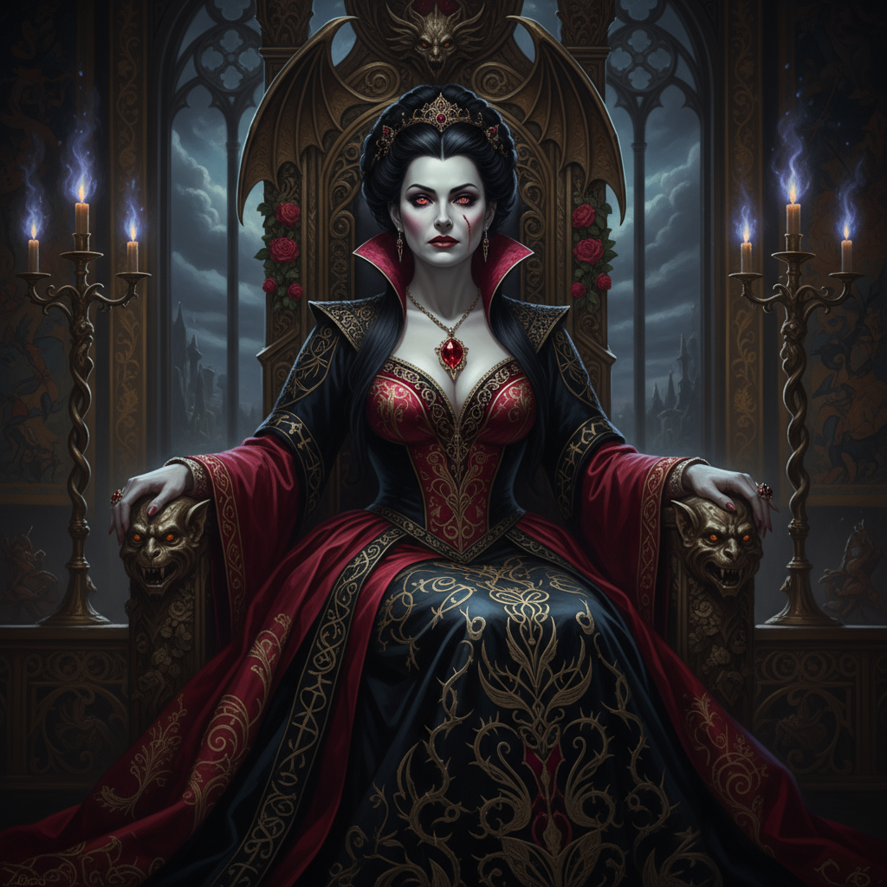

**Seraphiel - Portrait**

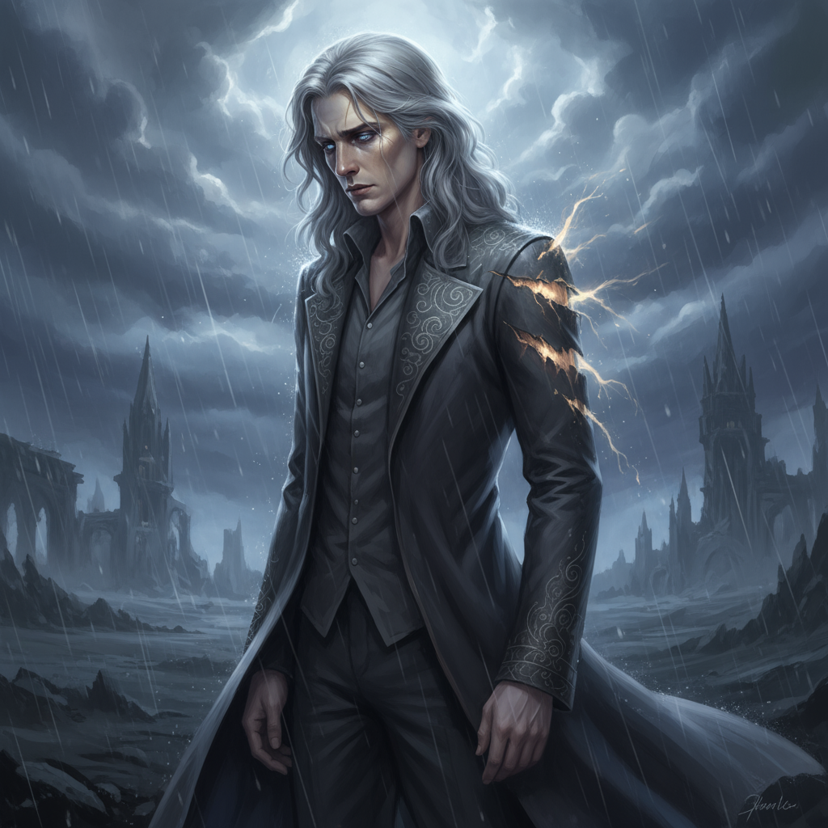

**Elara - Midnight Hunt**

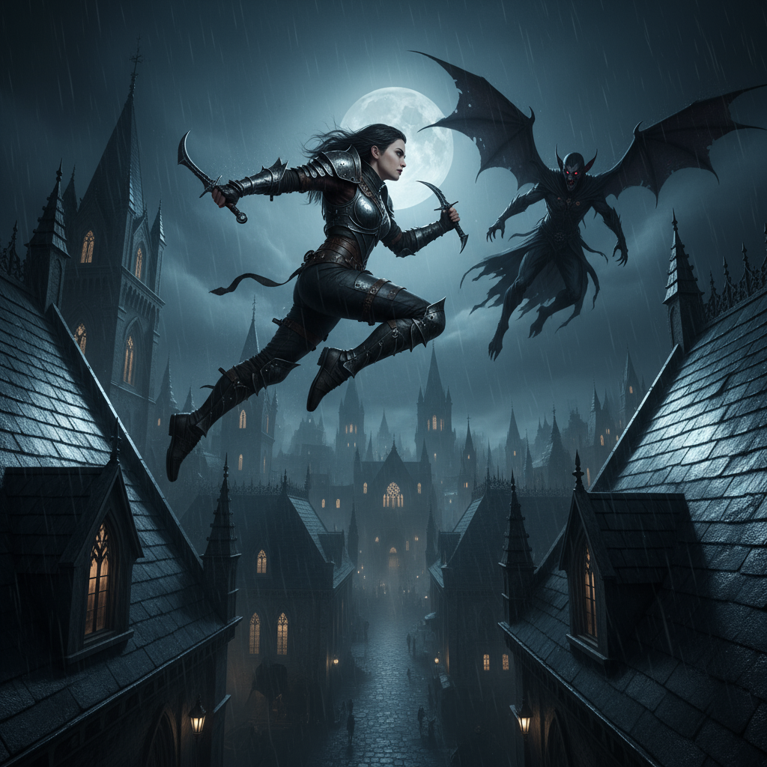

**Seraphiel - Celestial Powers**

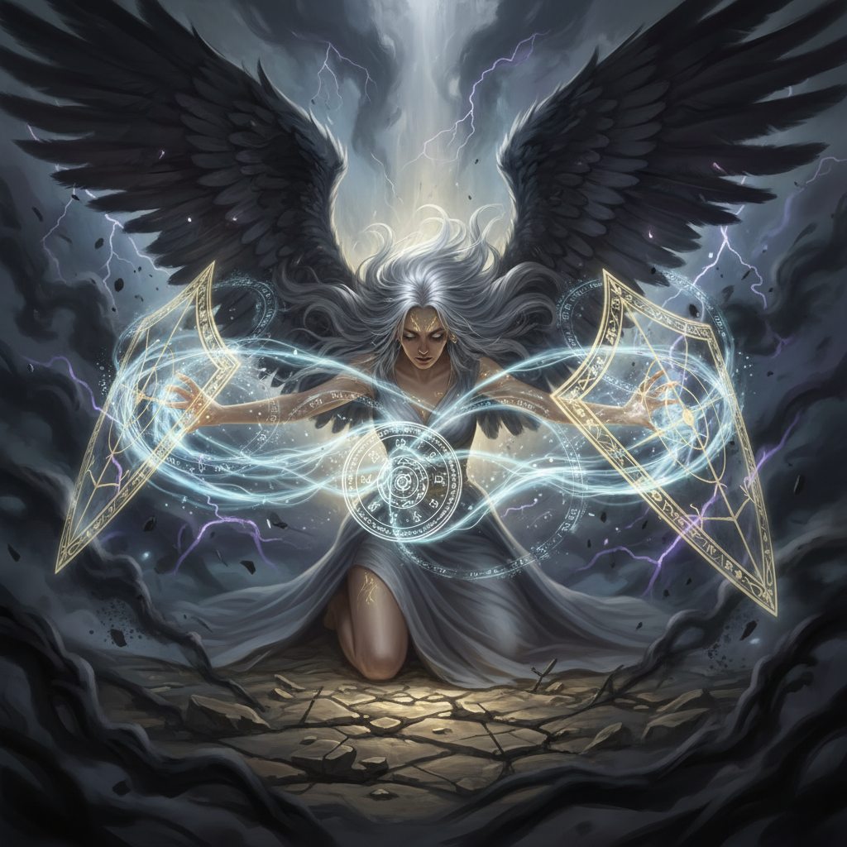

## Key Locations

**The Prophecy Chamber**

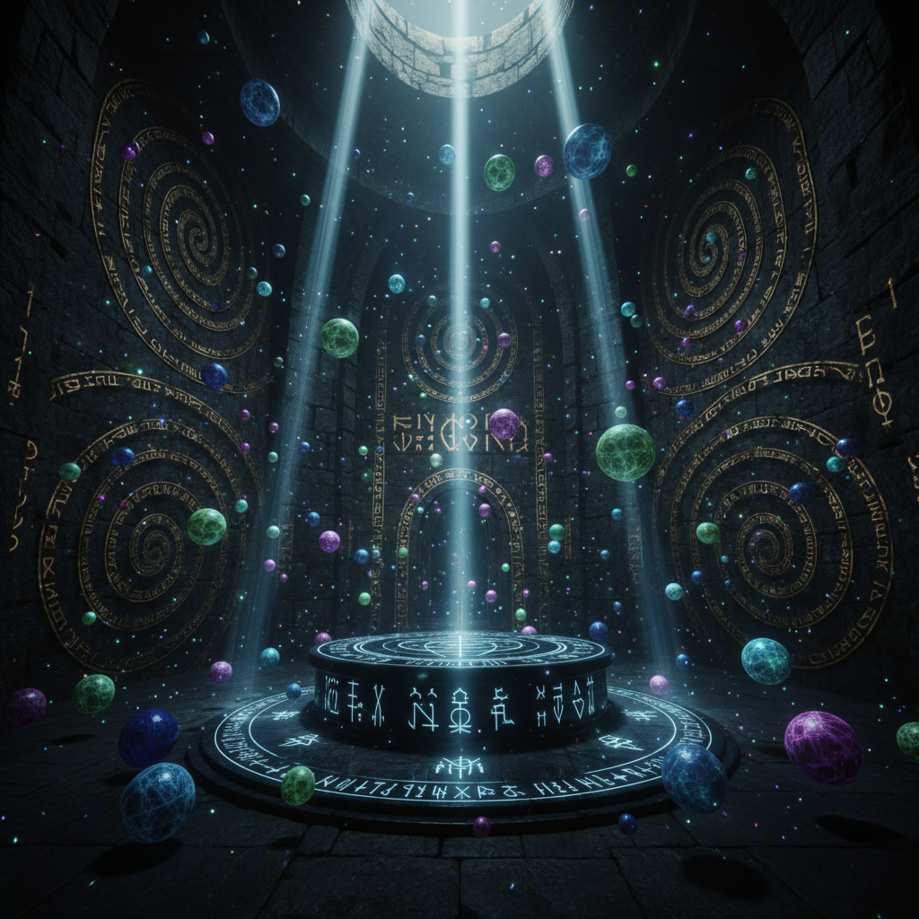

**Crimson Court Throne Room**

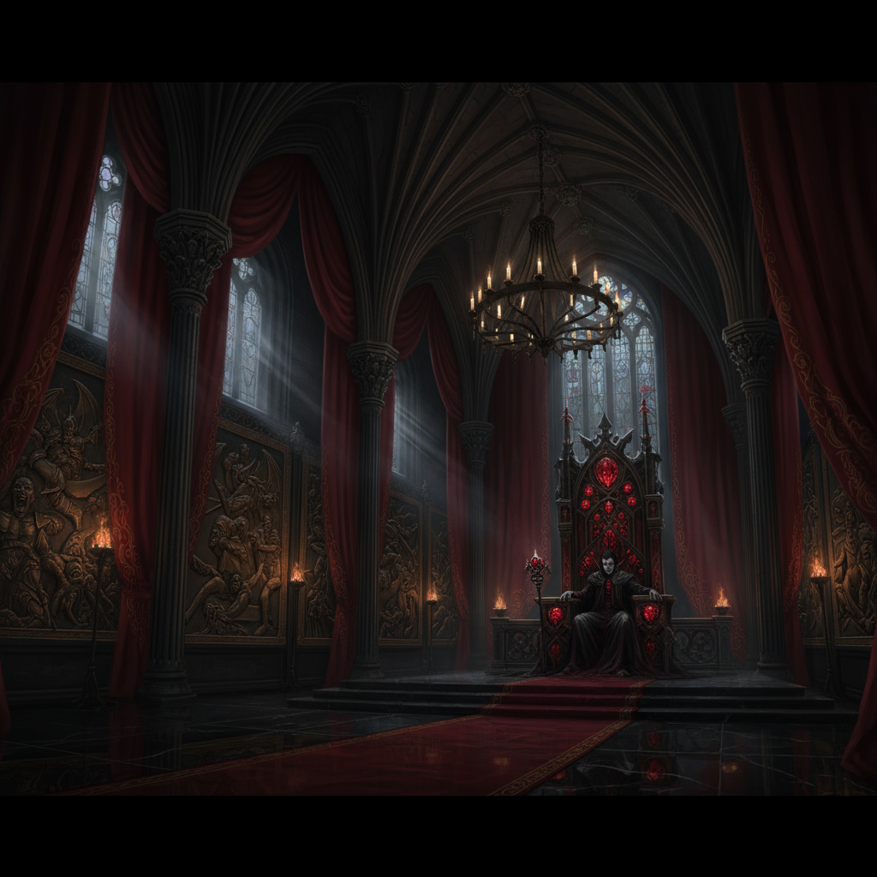

**Rebel Encampment**



**Blood Moon Fortress**

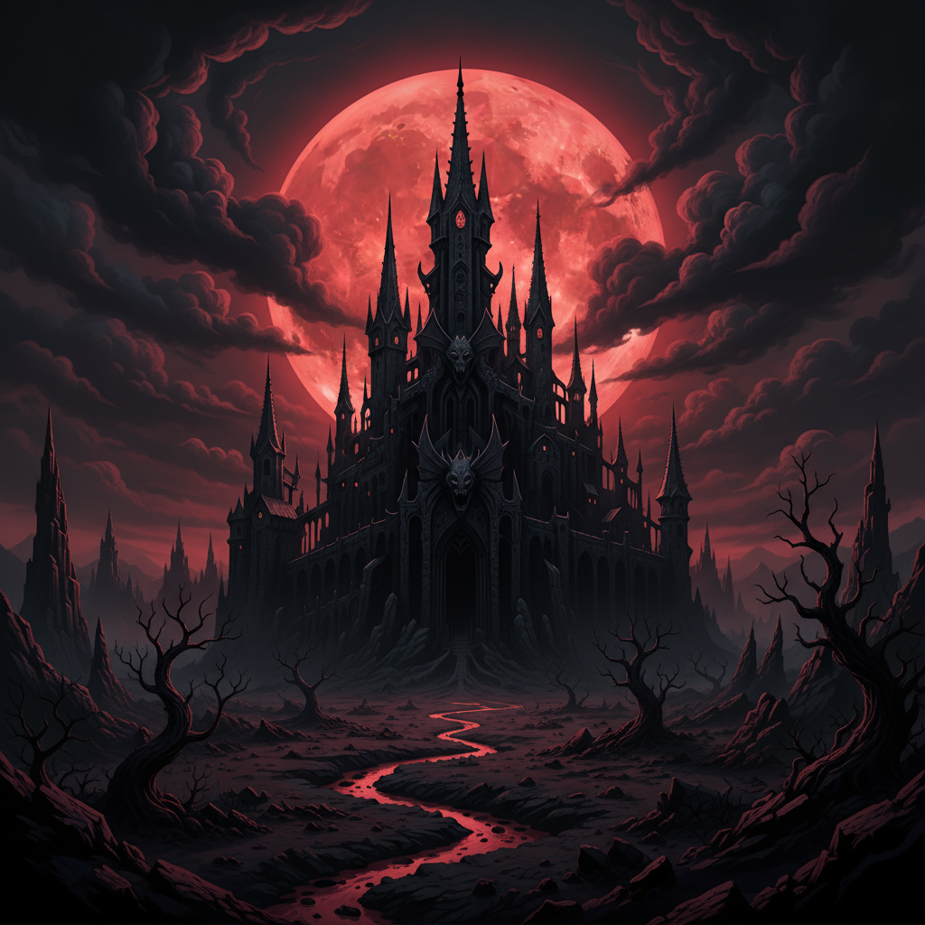

## Key Scenes

**Elara vs Lysandria - Confrontation**

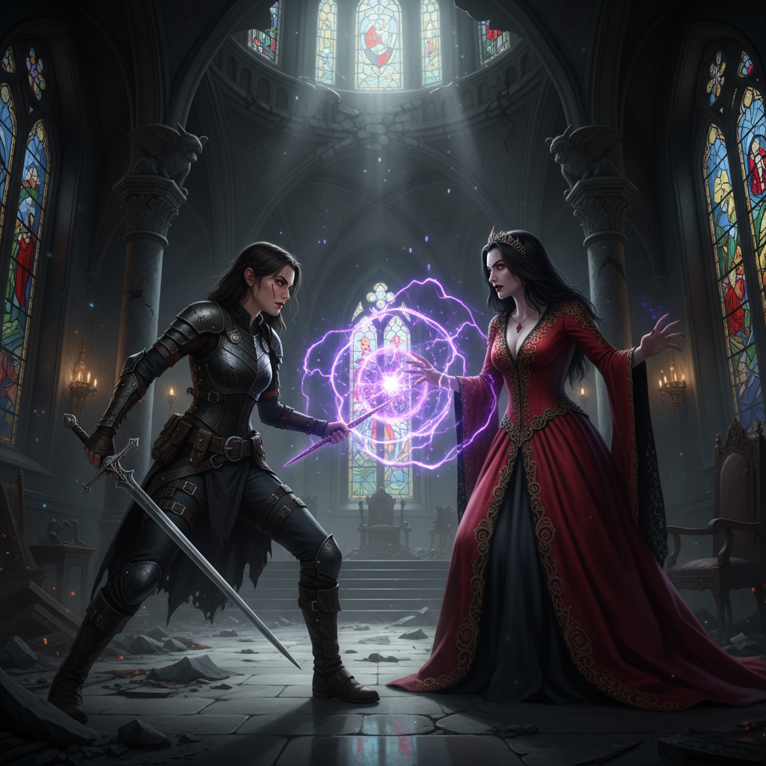

**The Nightbringer Manifestation**

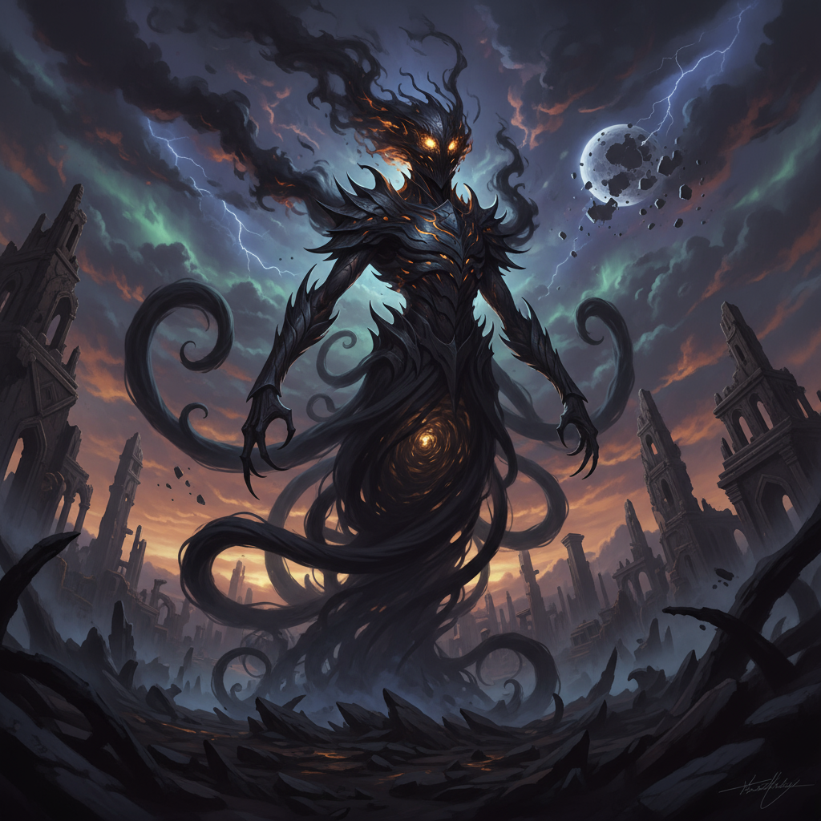

**The Twilight Accord Signing**

